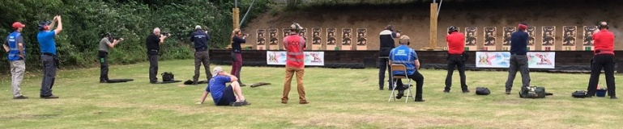
DRPC1999 COMPETITION RESULTS 2021

15TH August

Timed & Precision 1 Club Competition.

This was held for four Gallery Rifle classes, Small-bore, Centrefire, Long Barreled Pistols and Long Barreled Revolver.

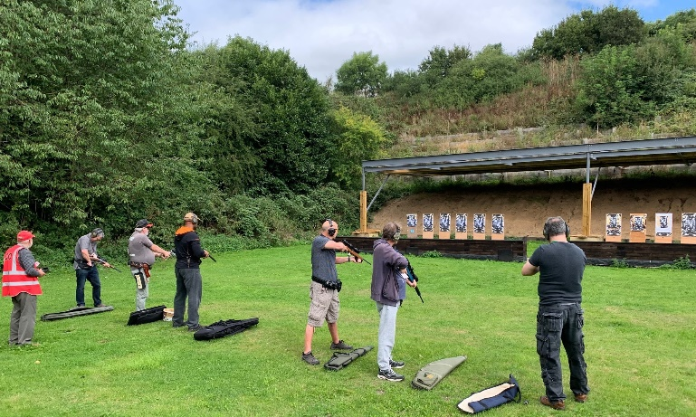
There was a reasonable number of entrants and CRO Jim St ran them through with the help of the two duty CROs Rodger and Mike.

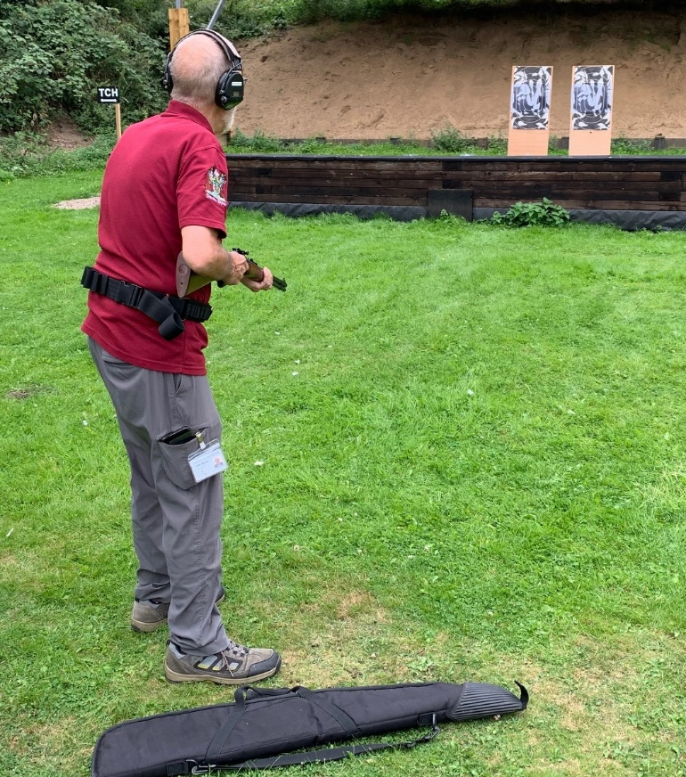
Jim Sm was the last shooter of the day and used his iron sighted Classic for the centrefire – Bad choice.

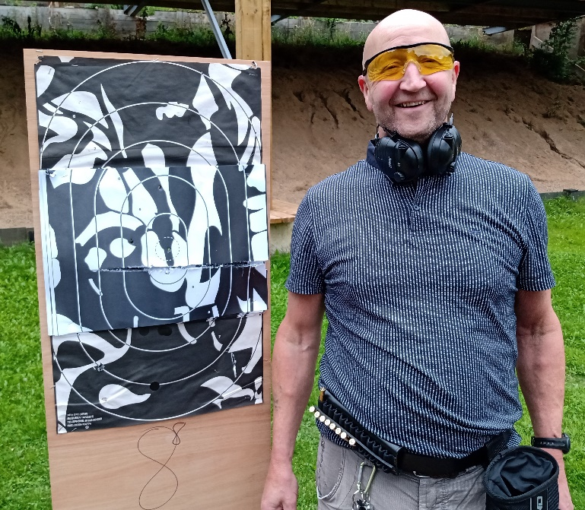
Jim Sinc almost cut his target in half with a late shot as the targets turned away. - More practice needed!

Congratulations to the winners

GRSB
Jim St | 299.014
Tim T | 287.003
Mark S | 282.006
Darren | 276.005
Jim Sin | 272.005
Nigel L | 272.004
GRCF
Jim St | 300.022
Jim Sm (Classic) | 297.011
Tim T | 282.007 | 3rd on Countback
Jim Sin | 282.007
Nigel L | 270.005
LBP
Bob P | 291.007
Jim Sm | 290.007
Mark S | 286.003
Jim Sin | 265.007
LBR
Jim Sm | 292.009
Bob P | 272.003

